**Project Title – Bearcat Carpooling.**

**Team Members – Harshitha Chetty Ragava**

**Vamshi Krishna Nuka**

**Gouthami Pasham**

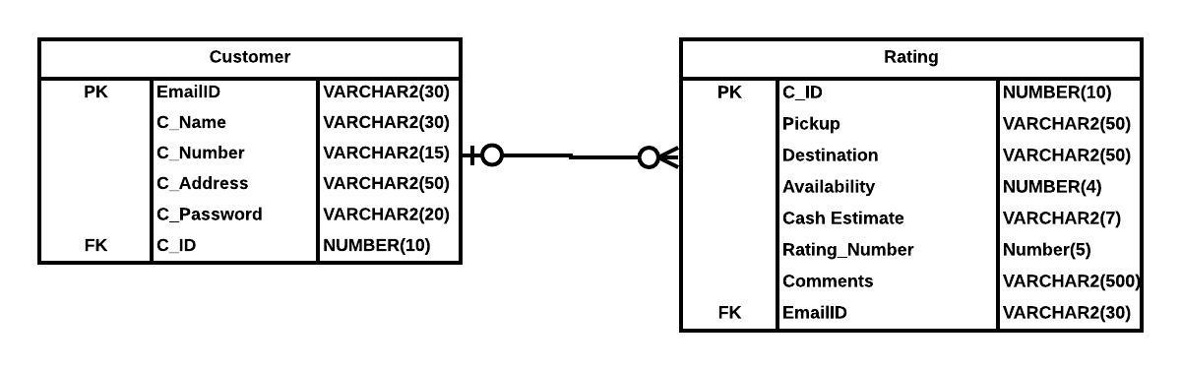

The ER Diagram for the carpooling android application is illustrated above.

This consists of two tables Customer and Rating.

The relation between the Customer and Rating table is Optional One to Optional Many as a customer has an option to give the rating or skip it depending on his/her will. These ratings can be none, one, and many depending on the customer rides.

Customer Table –

* EmailID – This is the primary key of Customer table. It acts as a log in credential for the application with password. It has limit of 30 characters.
* C_Name – This attribute stores the name of the customer with a limit of 30 characters. It is used for communication.
* C_Number – This attribute stores the customer mobile number for contacting, sending updates of ride, details. It has a limit of 15.
* C_Address – This attribute stores the address of the customer with a limit of 50 characters.
* C_Password – This attribute stores the password of the user which is one of the credentials required for logging into the application with a limit of 20 characters.
* C_ID – This is a foreign key pointing to Rating Table.

Rating Table –

* C_ID – This is the primary key of Rating Table which is generated in the application once the user is registered into the application with a limit of 10 numbers.
* Pickup – This attribute stores the location or pickup details of the customer with a limit of 50 characters.
* Destination – This attribute stores the location details the user wants to go and has the same limit of 50 characters.
* Availability – This attribute gives the customer the information of number of seats available in a particular vehicle where he/she can select the required vehicle for commuting.
* Cash_Estimate – This attribute on giving the pickup, destination and vehicle details estimates the cost for the journey.
* Rating_Number – This attribute stores the rating of the customer.
* Comments – This attribute stores the feedback of the customer with a limit of 500 characters.
* EmailID – This is a foreign key to link with the Customer Table.